**HERMES**

**Table of Contents**

1. Brief Introduction to HERMES
2. HERMES Pages
   1. Login. . . . . . . . . . . . . . . . . . . . . . . . . . . . . . . . . . . . . . . . . . . . . . . . 3
   2. Sign Up. . . . . . . . . . . . . . . . . . . . . . . . . . . . . . . . . . . . . . . . . . . . . . 4
   3. Billing screen. . . . . . . . . . . . . . . . . . . . . . . . . . . . . . . . . . . . . . . 5
   4. Barcode generator. . . . . . . . . . . . . . . . . . . . . . . . . . . . . . . . . . 6
   5. Purchase Screen . . . . . . . . . . . . . . . . . . . . . . . . . . . . 7
   6. Day Book . . . . . . . . . . . . . . . . . . . . . . . . . . . . . . . . . 8
3. Technical Details

Introduction

Managing a retail store efficiently in this day and age has become quite cumbersome. The store manager has to juggle numerous issues and come up with solutions to tackle these issues. The Point of Sale system presented in the paper uses a multiplatform desktop application, an Android application along with a database server, internet connection and a router to help manage the store remotely. Identifying store items with a barcode scanner, completing retail transactions and generating bills are the three main tasks performed by the system. The system can be configured to either run as a centralized system or as a distributed system. The Point of Sale system also managed to demonstrate the important characteristics of high efficiency, platform independence and being user-friendly.

**LOGIN:**

The software is divided into two parts front end and backend. It is done so that it can work as both desktop application and web application. In order for the software to run you need to setup the server side of the application based on the database driver you want to use.

For the software to run as a desktop application you will have to setup the QDBC driver. For the software to run as a web application you need to setup ODBC driver and configure it according to the DBMS software you are running.

Given below are the screenshots of the software:

First you need to login to the software:

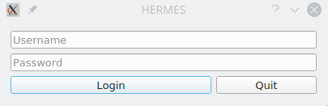

**SIGNUP:**

You will be served with a screen as given below:

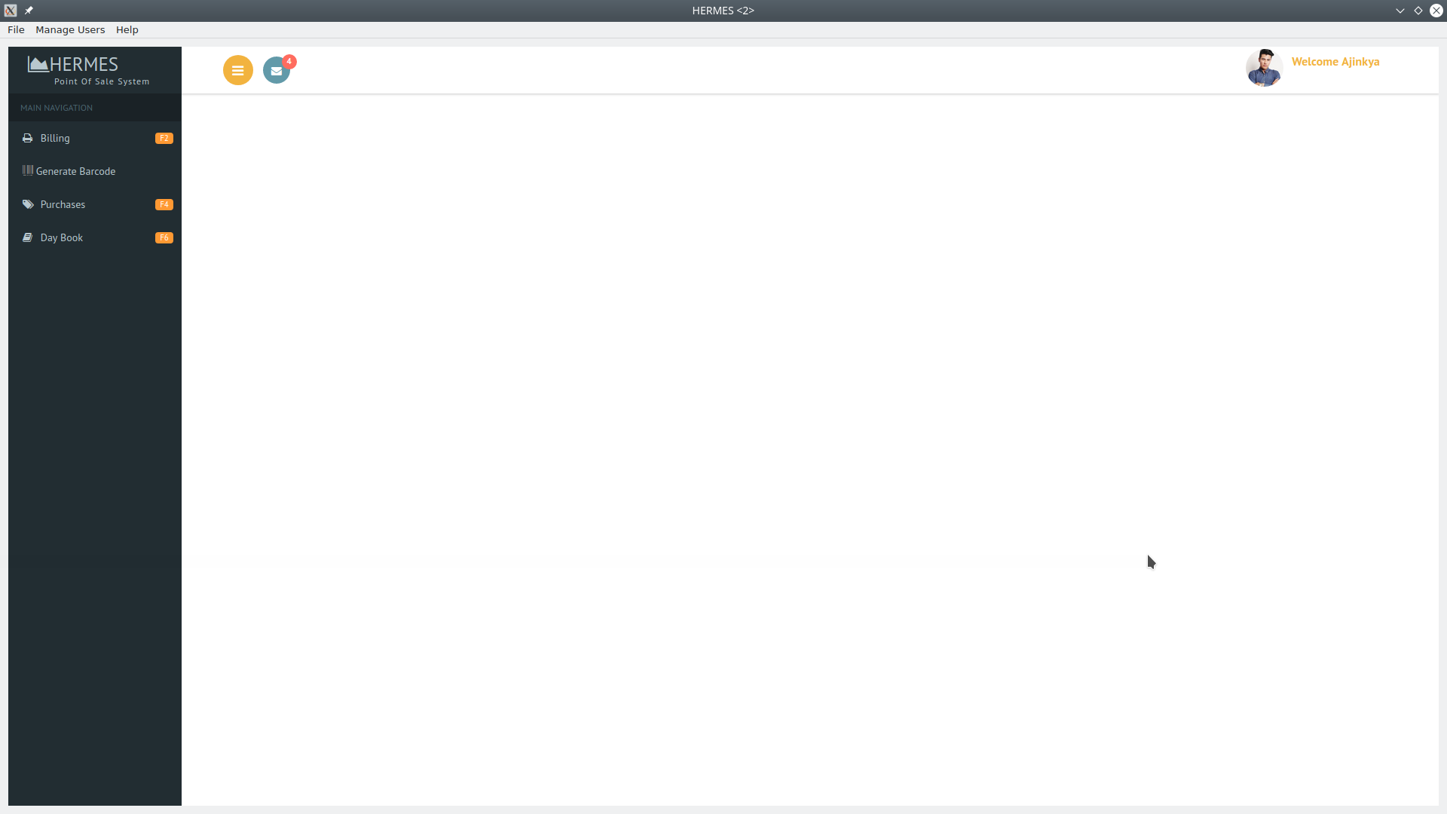

**BILLING SCREEN:**

Press F2 or click billing tab to go to the billing screen:

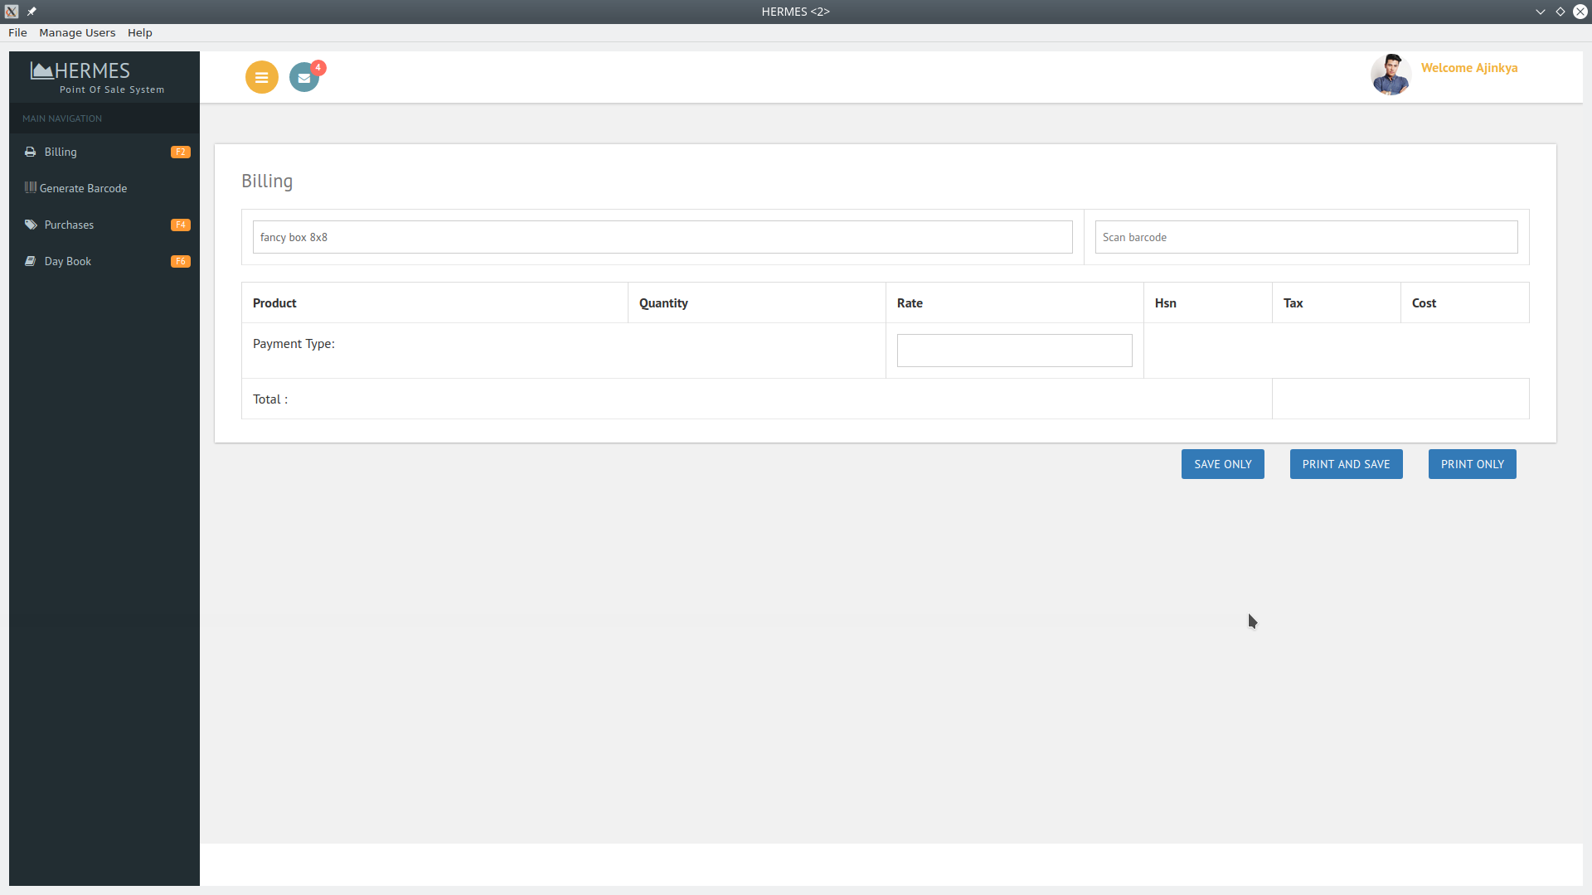

**BARCODE GENERTAOR:** Press the generate barcode to go to the barcode screen: select item and click generate barcode to generate barcode.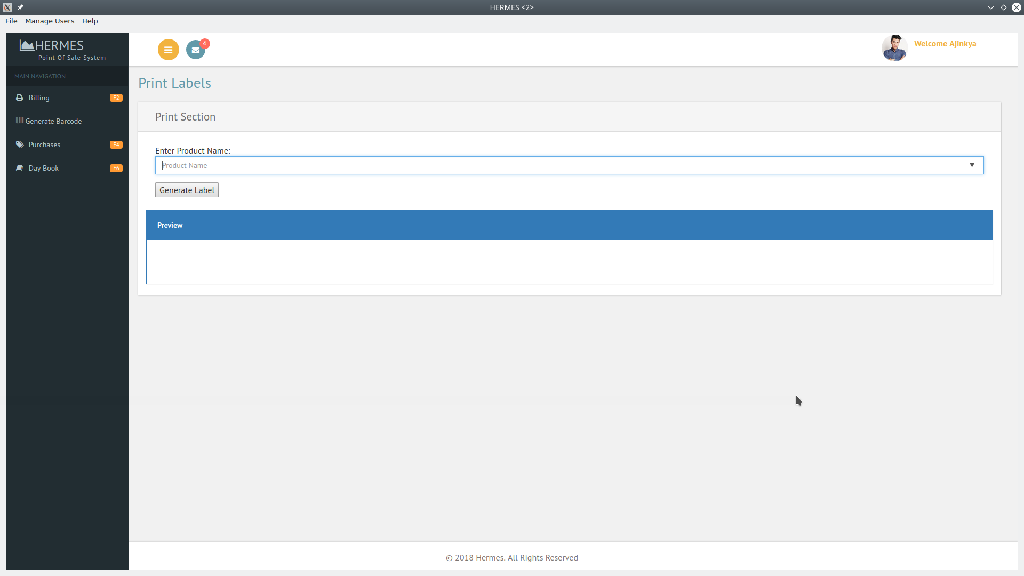

**PURCHASE SCREEN:**

To buy something for the store you will have to go to purchase screen by clicking on the tab or press F3:

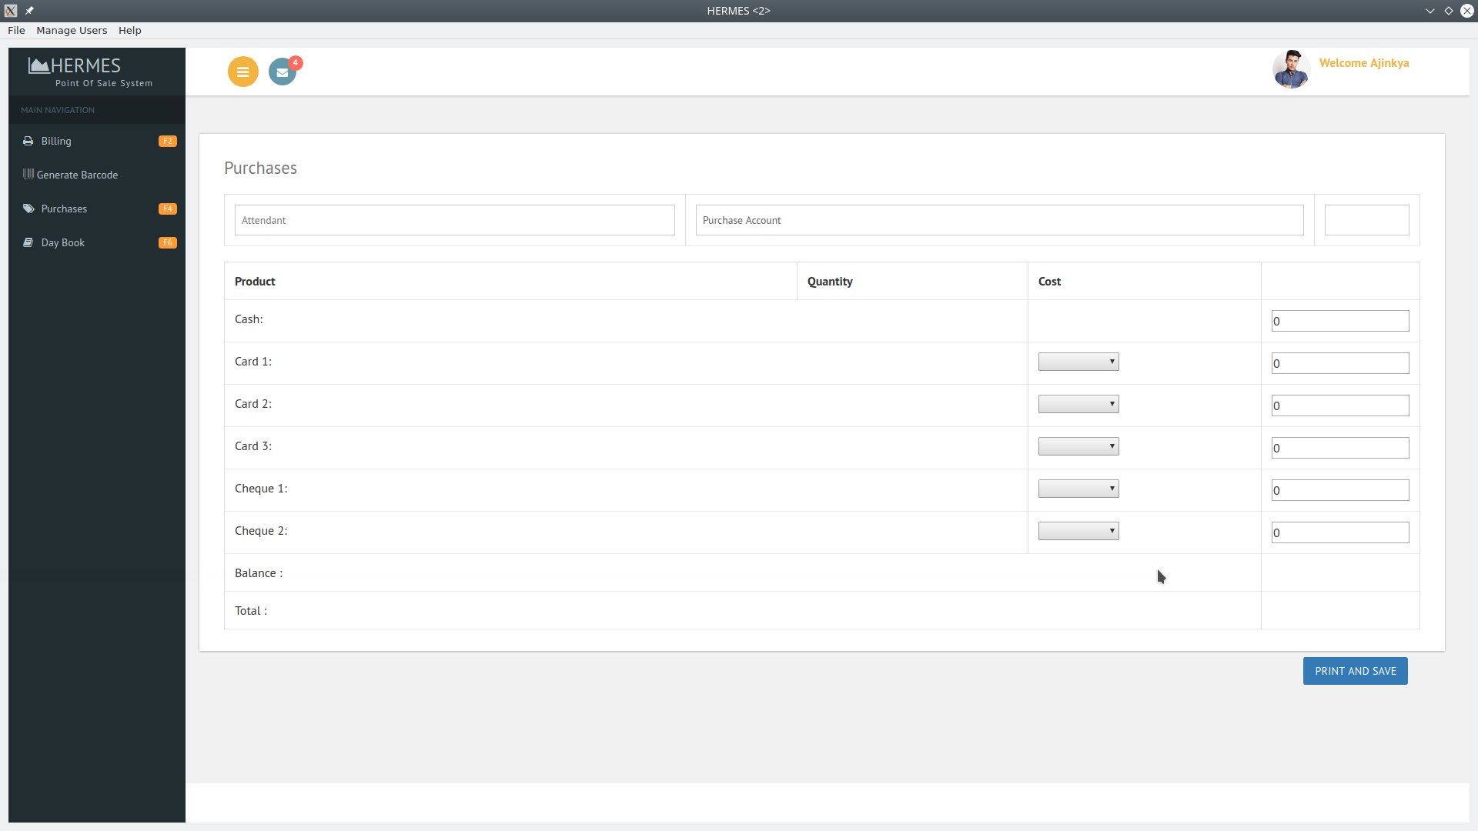

**DAYBOOK:** To view daybook press F6 or click on the Day book tab, enter the date and you will info about that day sales: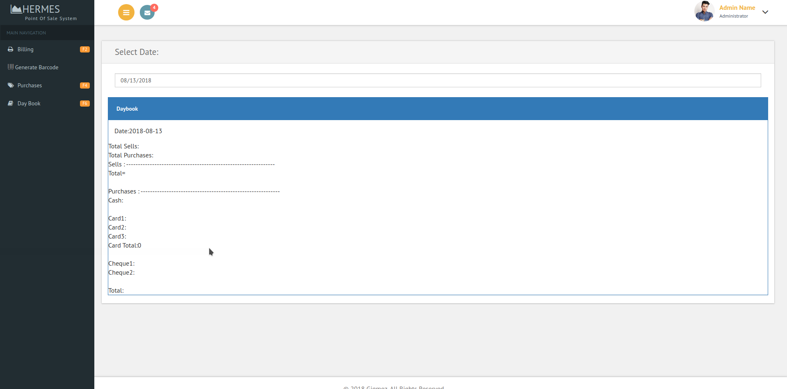

**Technical Details**

1. User Interface:

The user interface of the software is developed using QT framework. For the web app the user interface is developed using html, css and javascript. Both the software and the web app make use of AJAX to load the data dynamically.

2. Backend:

For backend we have made use of PHP and MYSQL. However, for the software to be able to work with the database, we need to setup QDBC. For the POS library that helps generate barcode and printing functionality you need to setup ODBC. Web app requires ODBC as well to interact with the POS library and the database.

3.Recommended algorithm:

The front end as well as the backend is developed using procedural method of programming. Linear search algorithm is used to extract elements from the database.